Looking for a new research opportunity?
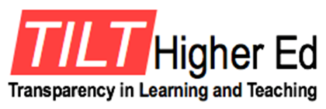
Participate in UNI’s
Project!
The CETL is looking for faculty who are interested in finding out how transparent teaching practices affect UNI students.
Here are some possible project options. Work individually or in a team to:
- Compare course grades in a previous iteration of a course and in a course using transparent assignments.
- Compare retention/success of students in sequenced courses in a major. Do transparent teaching practices encourage more students to persist to the next course in a sequence?
- Compare student evaluation comments in a previous course with a current course in which transparent teaching practices are used.
- What other possibilities can you imagine?

As a part of TILT Research, faculty will
- Alter two assignments using transparent processes;
- Have students complete pre-and post-surveys in your course;
- Score student work samples;
- Reflect on transparent teaching process and their effect on your course;
- Meet with others implementing transparent teaching in their courses and/or with your research team;
- Publish findings.

What’s in it for you?
- Publication(s);
- Contribute to the scholarship of teaching and learning and the research on transparent teaching;
- Work with other interested colleagues;
- Possible faculty development funds.

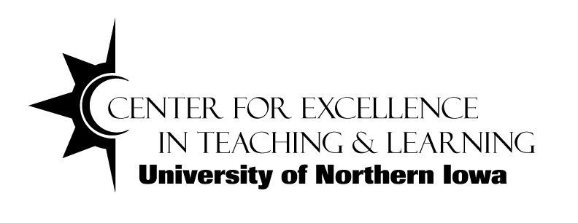
If you are interested in having a conversation about how you can participate in UNI’s TILT Project, please fill out the card on the table.

